Creating Organizational Unit (OU)

In Active Directory,

Create Secuty Group,

Create new User

Project Overview:

I will create an organizational unit (OU) on Active Directory Domain Services and name the OU HR department. Inside the HR department, I will create the first user in the HR OU, User John Doe, as the first user in that department. Inside the HR organizational unit, or OU, I will create a security group for the HR department and add the new John Doe as a member of the security group for the HR department.

Operating System

*Windows Server 2025*

Client Computer

*Windows 11 Professional*

1. Login to the domain controller windows server 2025

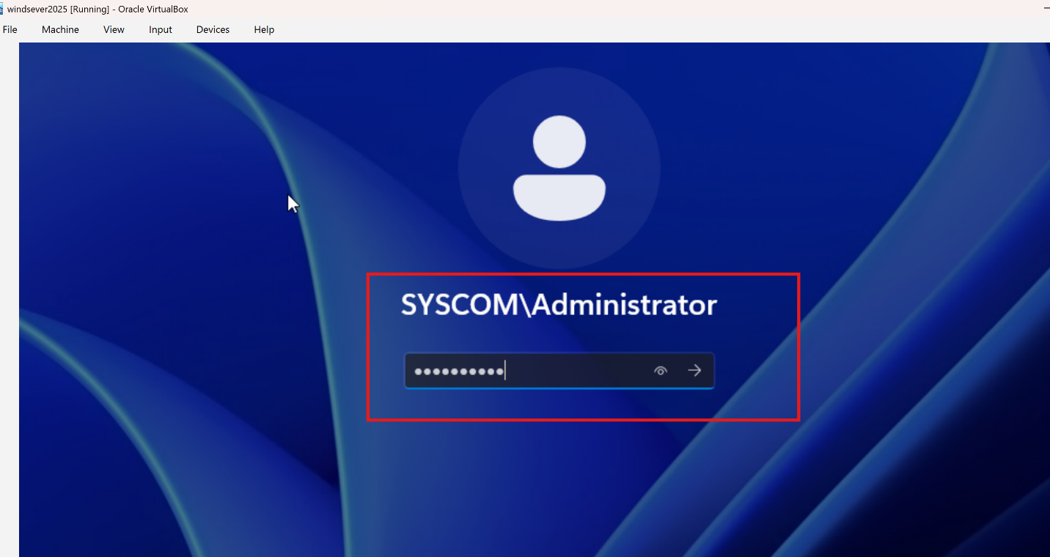

1. Click on start on the server > click on Server manager > tools > active Directory and Domain Services

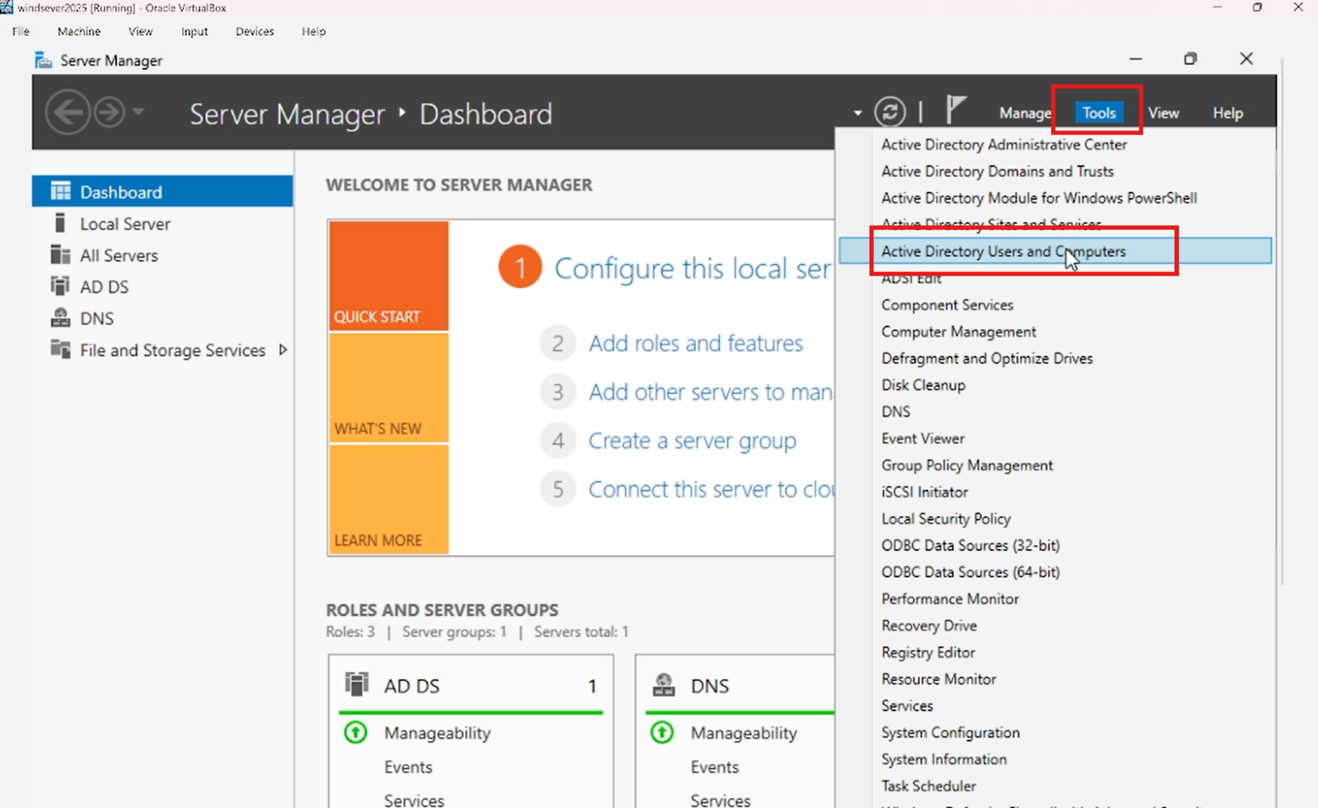

1. On active directory users and computers select Syscom.local > right click > new > organizational Unit

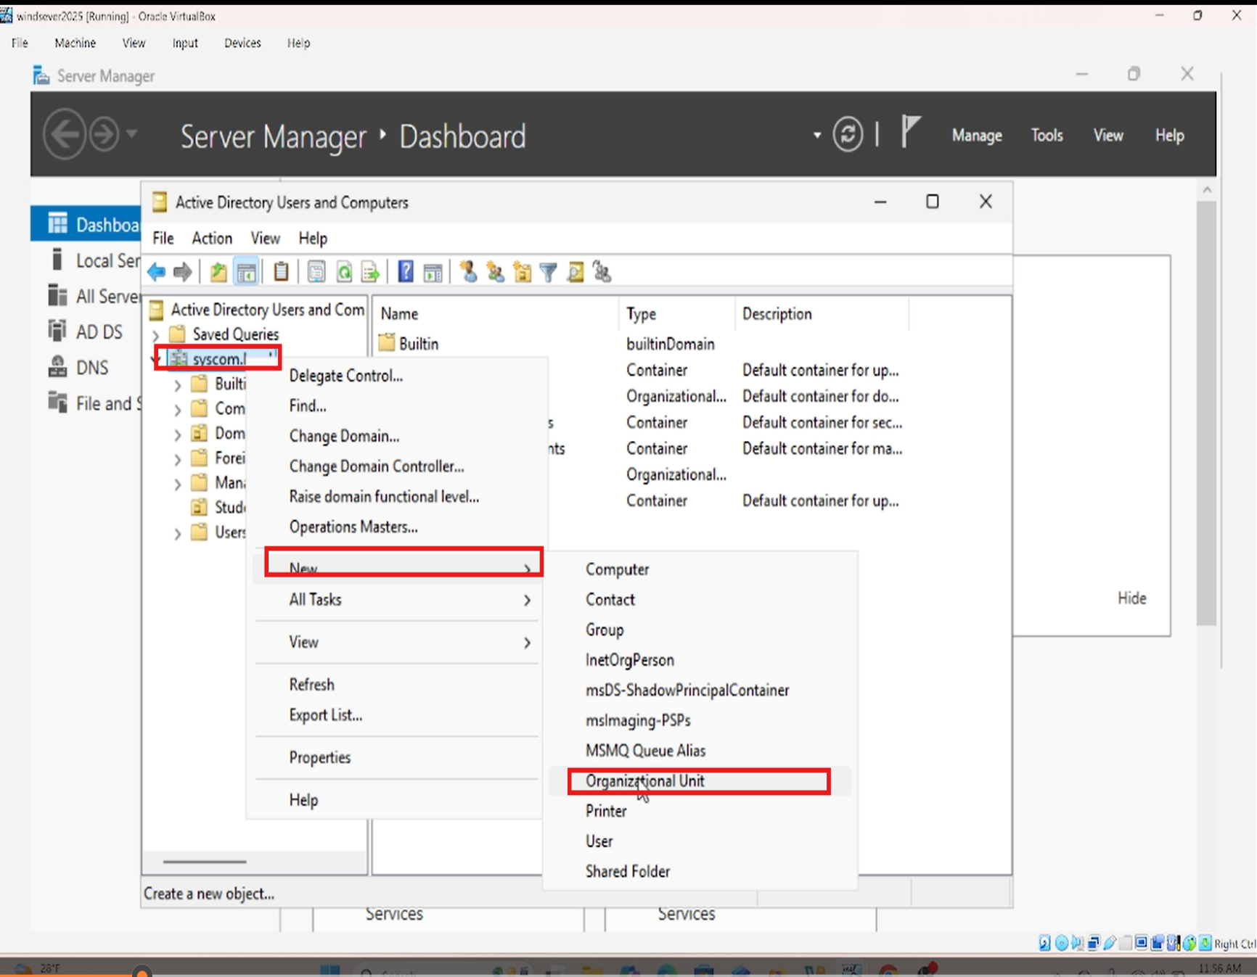

1. Name the organizational unit “HR Department” > *check the box protect container from accidental deletion > click on OK*

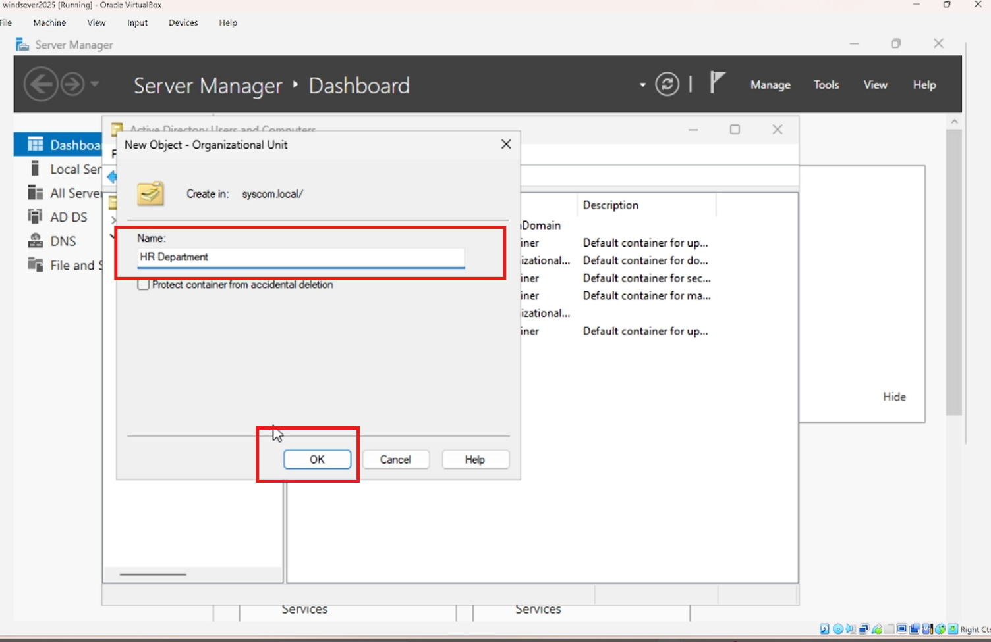

1. Create new user John Doe. Right click on the HR OU department > New > User

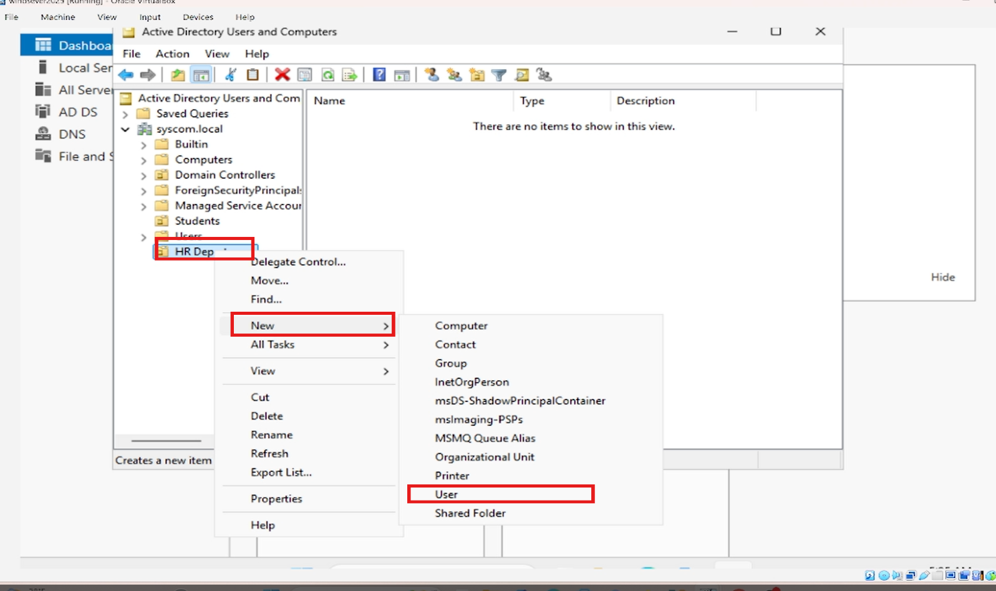

1. Fill out the User information first name: John, Last Name: Doe, Username jodoe, click on next, and click on finish.

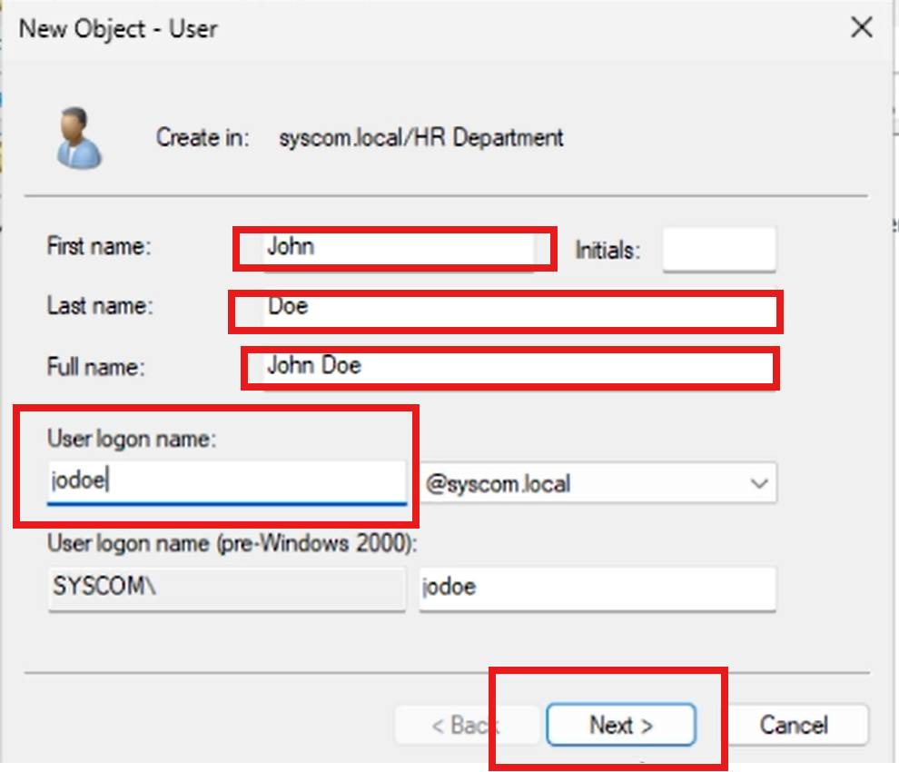

1. Set a password *UHBggdnnf*@#* for the user and click Next, and click on **Finish**

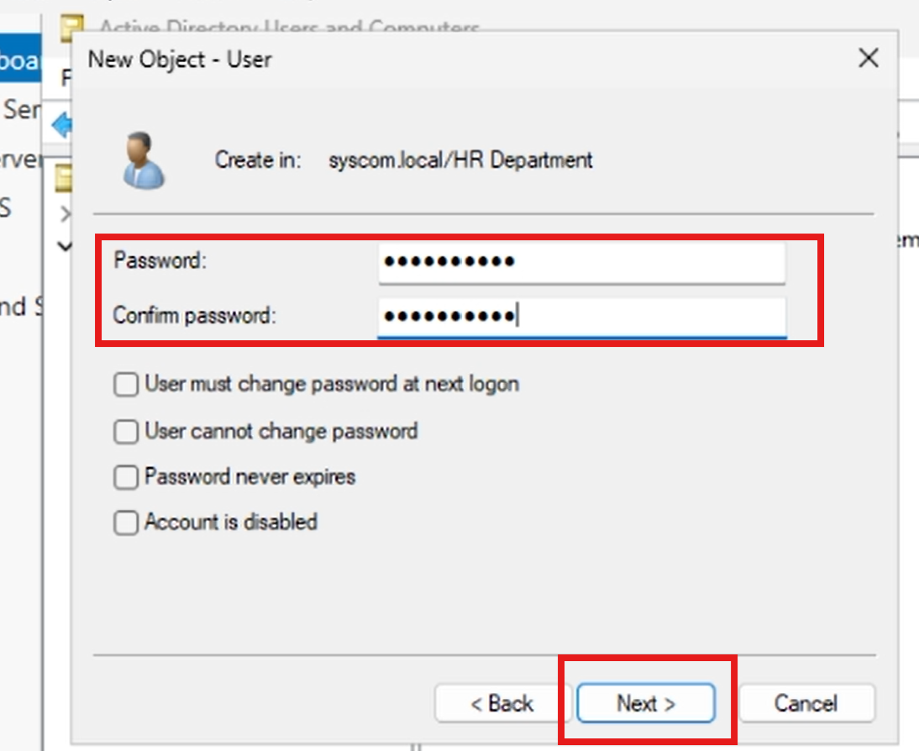

1. The result below shows that the new user was successfully created

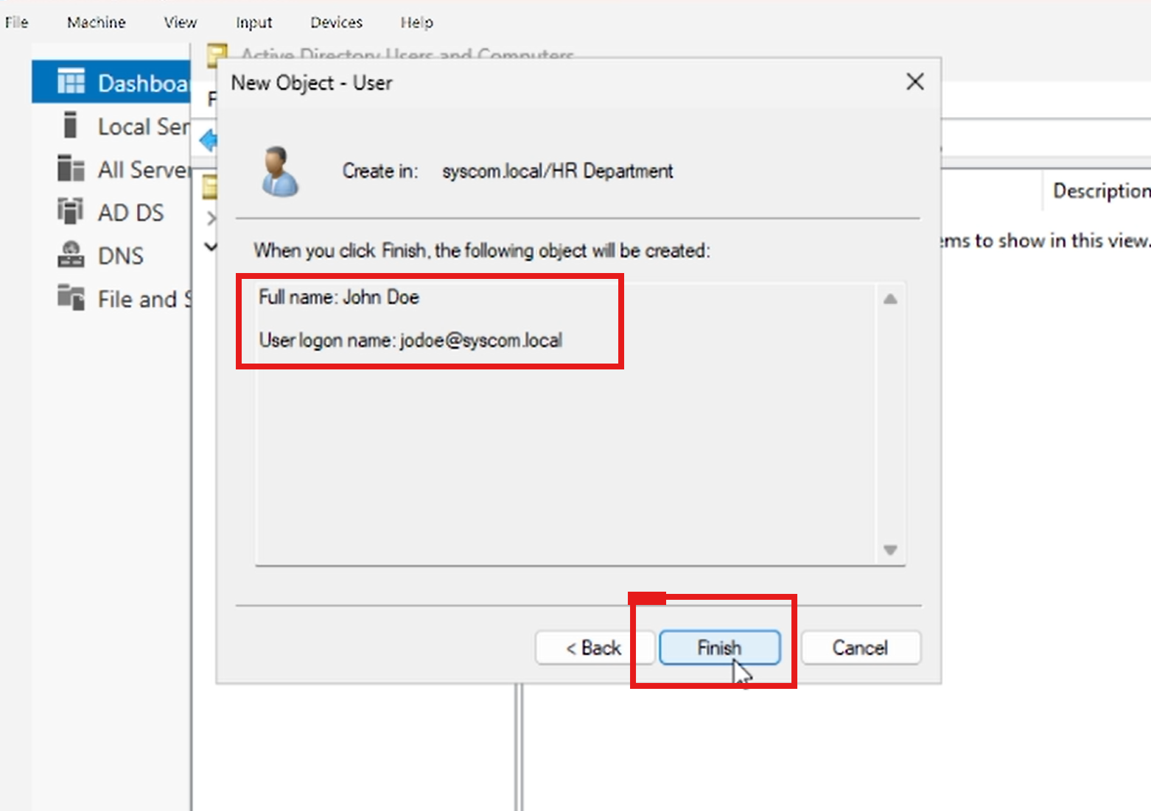

1. Creating a group for the HR department. Right click on HR Department > new > name the group HR dept > click on OK

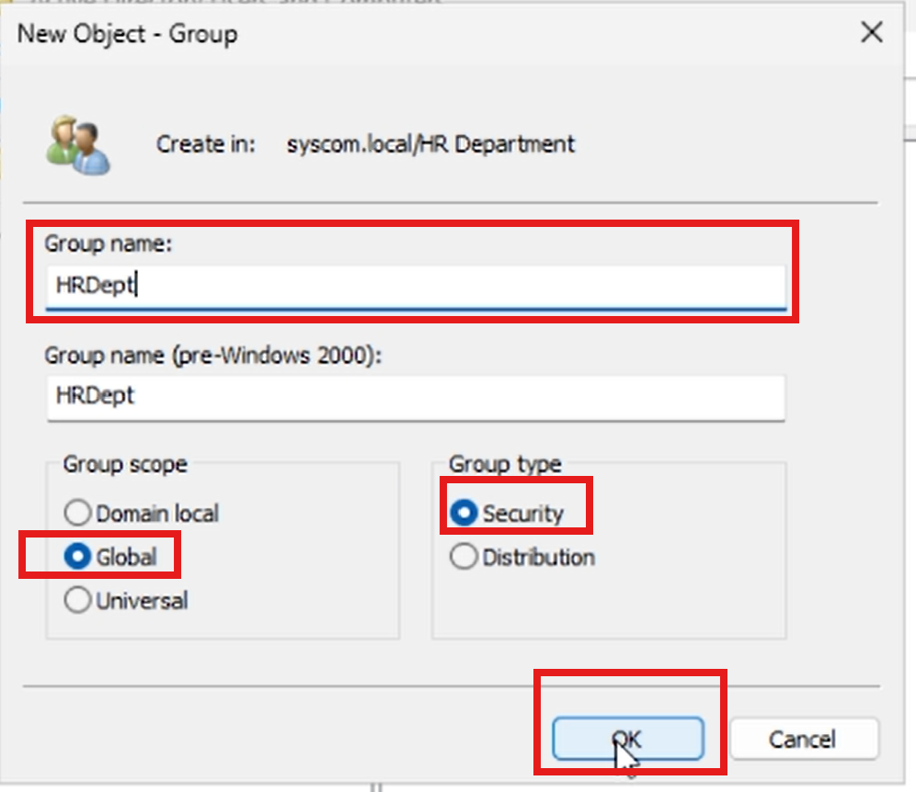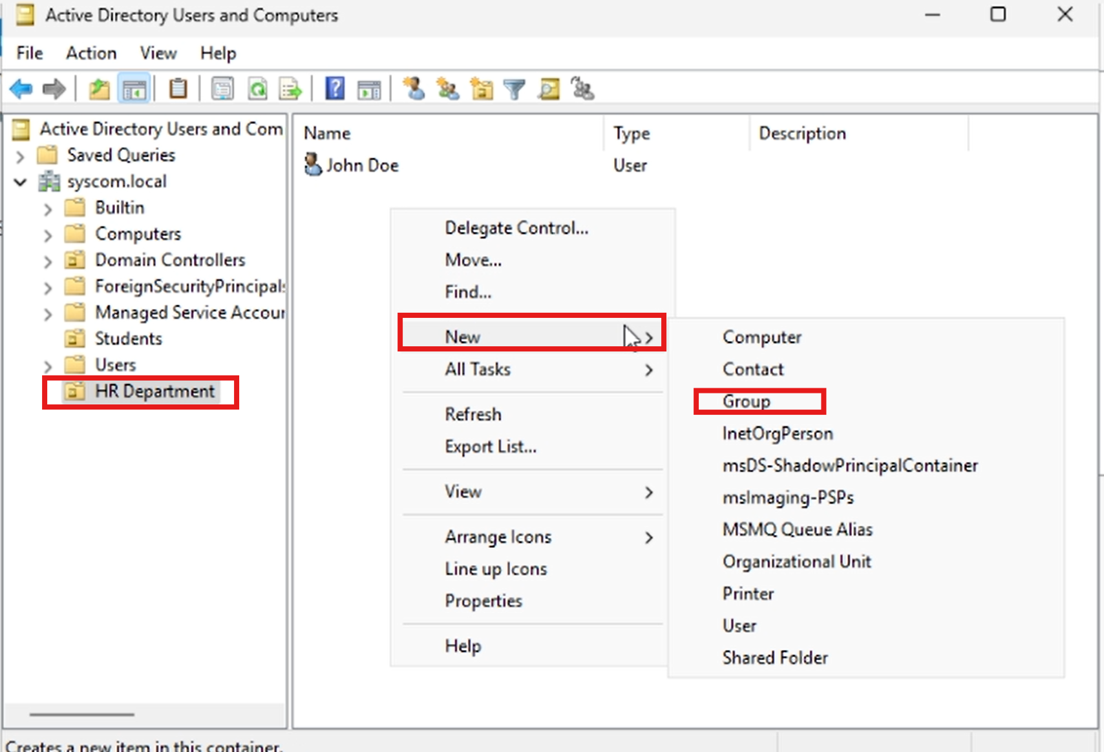

1. Adding john Doe as member of the HR dept group. Right click on HRDept > properties

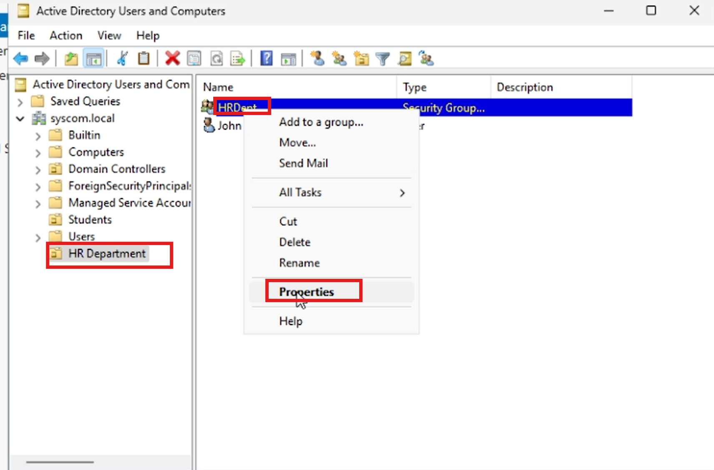

1. 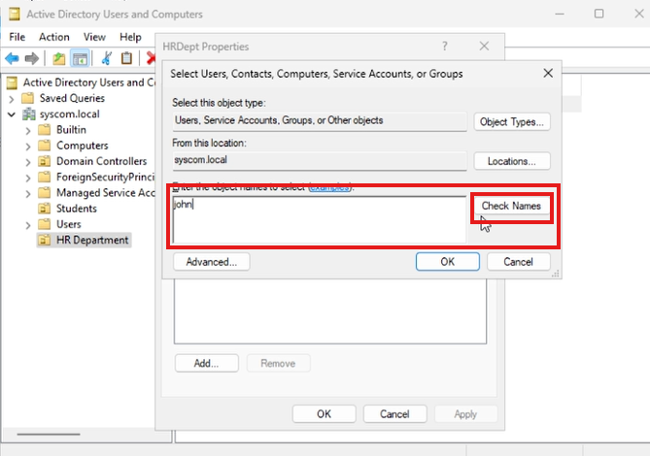Click on the members tab > add > type the user “John” > click on check names > click on OK
2. Click on apply > OK

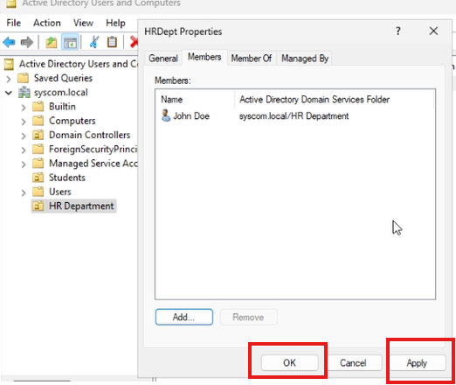

1. Test login user John Doe on the Client Windows 11 Virtual machine with username jodoe and password. Username: jodoe Password: ***UHBggdnnf*@#***

